ONLINE BUS RESERVATION

A Project Report

submitted in partial fulfillment of the requirements

of

…………….Track Name Certificate……………..

by

**PK Shashankan,822720106038**

**D Prasaanna,822720106031**

**S Arockia joshua,822720106005**

**S Sivabharathi,822720106041**

Under the Esteemed Guidance of

**Mrs.Uma Maheswari R**

**ACKNOWLEDGEMENT**

We would like to take this opportunity to express our deep sense of gratitude to all individuals who helped us directly or indirectly during this thesis work.

Firstly, we would like to thank my supervisor,**Mrs.Uma Maheswari R,** for being a great mentor and the best adviser I could ever have.

I express my sincere thanks to **Edunet Foundation** for providing the opportunity to carry out the placement training classes.

I sincerely thanks **Mrs.Uma Maheswrai R,GUIDE,** **EDUNET FOUNDATION,** For his kind patronage and for all the facilities offered to do this training successfully.

With deep sense of gratitude,immensely thank my guide, **Mrs.Uma Maheswrai R,EDUNET FOUNDATION,**for her guidance,encouragement and co operation.

Her advice,encouragement and critics are source of innovative ideas inspiration and causes behind the successful completion of this dissertation.

The confidence shown on me was the biggest source of inspiration for me.

Her talks and lessons not only help in thesis work and other activities of college but also make me a good and responsible professional.

I am like to express our hearty thanks to **Mrs.Uma Maheswrai R,Guide** for her constructive criticism through my training.

I would have never succeeded in completing my placement training work without the cooperation of technical team in **EDUNET FOUNDATION**

#### ABSTRACT

An online bus reservation system is a web-based application designed to facilitate the booking and management of bus tickets through the internet. Users can access the platform to search for available bus routes, view schedules, select seats, and make reservations or purchases online. The abstract functionalities of an online bus reservation system typically include:

1. *User Registration and Login:* Users can create accounts, providing necessary details, and log in securely to access the system.

2. *Search and Bookings:* Users can search for available buses based on routes, timings, and other parameters. Once satisfied, they can proceed to book tickets, choosing specific seats and making reservations.

3. *Seat Selection:* The system allows users to view the layout of the bus and select seats according to their preferences.

4. *Payment Processing:* Integration with payment gateways enables secure online transactions for ticket purchases.

5. *User Profiles:* Users can manage their profiles, view booking history, and make modifications or cancellations if allowed.

6. *Real-time Updates:* Users receive timely notifications about their bookings, including confirmation details and any changes to the schedule.

7. *Admin Dashboard:* Administrators have access to a dashboard where they can manage bus schedules, seat availability, user accounts, and monitor overall system activities.

8. *Reporting and Analytics:* The system may offer reporting tools to generate insights into user behavior, popular routes, and financial transactions.

9. *Security Measures:* Implementation of security protocols to safeguard user data, financial transactions, and system integrity.

10. *Feedback and Reviews:* Users can provide feedback and reviews, contributing to the improvement of services.

An efficient online bus reservation system enhances the overall travel experience by providing a user-friendly interface, real-time information, and a secure booking process. It streamlines the traditional ticketing system, offering convenience to both passengers and service providers.

**TABLE OF CONTENTS**

1. *Introduction*

- 1.1 Background

- 1.2 Purpose

- 1.3 Scope

- 1.4 Objectives

- 1.5 Key Features

2. *System Architecture*

- 2.1 Frontend Components

- 2.2 Backend Components

- 2.3 Database Structure

- 2.4 Integration Points

3. *User Roles and Permissions*

- 3.1 Administrator

- 3.2 Registered User

- 3.3 Guest User

4. *User Interface Design*

- 4.1 Home Page

- 4.2 Registration and Login

- 4.3 Bus Search and Booking

- 4.4 Seat Selection

- 4.5 Payment Processing

- 4.6 User Profile

5. *System Functionality*

- 5.1 Bus Schedule Management

- 5.2 Seat Availability

- 5.3 Booking and Reservation

- 5.4 Payment Integration

- 5.5 Real-time Notifications

- 5.6 Modification and Cancellation

6. *Security Measures*

- 6.1 User Authentication

- 6.2 Data Encryption

- 6.3 Secure Payment Handling

7. *Admin Dashboard*

- 7.1 User Management

- 7.2 Schedule Management

- 7.3 Reporting and Analytics

8. *Testing and Quality Assurance*

- 8.1 Test Cases

- 8.2 Testing Strategies

- 8.3 Performance Testing

9. *Deployment*

- 9.1 Server Setup

- 9.2 Continuous Integration/Continuous Deployment (CI/CD)

10. *Maintenance and Support*

- 10.1 Bug Tracking

- 10.2 Updates and Enhancements

- 10.3 User Support

11. *Conclusion*

- 11.1 Achievements

- 11.2 Challenges

- 11.3 Future Enhancements

12. *References*

**LIST OF TABLES**

|  |  |  |
| --- | --- | --- |
| **CHAPTER** | **TOPICS COVERED** | **PAGE NUMBER** |
|  | INTRODUCTION | **9** |
|  | LITERATURE SURVEY | **12** |
|  | PROPOSED METHODOLGY | **14** |
|  | IMPLEMENTATION | **18** |
|  | SYSTEM INTEGRATION AND TESTING | **21** |
|  | RESULTS AND DISCUSSION | **25** |
|  | CONCLUSION | **29** |
|  | REFERENCES | **32** |
|  | APPENDICES | **34** |

*Introduction*

*1. Background*

The travel and transportation industry has witnessed a significant transformation in recent years with the advent of technology. The conventional methods of booking bus tickets, characterized by long queues and manual processes, are being replaced by more efficient and user-friendly online solutions. The introduction of an Online Bus Reservation System marks a crucial step towards enhancing the overall travel experience for passengers.

*2. Purpose*

The purpose of this online bus reservation system is to streamline and simplify the process of booking bus tickets, providing passengers with a convenient and secure platform to plan their journeys. This system leverages modern technologies to offer real-time information, seat selection, and secure online transactions, making it an indispensable tool for both users and service providers in the transportation sector.

*3. Scope*

The scope of the Online Bus Reservation System encompasses a comprehensive platform that enables users to search for bus routes, check schedules, select preferred seats, and seamlessly complete the booking process. The system caters to both registered users and guests, offering a user-friendly interface with robust backend functionalities for administrators.

*4. Objectives*

The key objectives of implementing this system include:

- Facilitating a user-friendly and intuitive interface for easy navigation.

- Ensuring real-time updates on bus schedules, seat availability, and booking confirmations.

- Enhancing the efficiency of bus reservation processes for both users and administrators.

- Providing a secure and reliable platform for online transactions.

*5. Key Features*

The Online Bus Reservation System boasts the following key features:

- *User Registration and Login:* Enables users to create accounts, log in securely, and manage their profiles.

- *Bus Search and Booking:* Allows users to search for available bus routes, view schedules, and make bookings with ease.

- *Seat Selection:* Provides an interactive seat map for users to choose their preferred seats during the booking process.

- *Secure Payment Processing:* Integrates with trusted payment gateways to ensure secure online transactions.

- *Real-time Notifications:* Sends timely notifications to users regarding booking confirmations, schedule changes, and other relevant updates.

This document outlines the architecture, functionality, and features of the Online Bus Reservation System, aiming to offer a comprehensive understanding of its design and implementation. As we delve into the subsequent sections, we will explore the various components, user interactions, and the overall efficiency of this system in meeting the needs of modern travelers.

*System Architecture of Online Bus Reservation*

The architecture of an Online Bus Reservation System involves a combination of frontend components, backend components, databases, and integration points. Here is an overview of the system architecture:

*1. Frontend Components:*

- *User Interface (UI):* The UI layer is responsible for presenting information to users and facilitating their interactions. It includes web pages, forms, seat selection interfaces, and other components.

- *User Input Handling:* JavaScript, HTML, and CSS are utilized to handle user input, validate form submissions, and ensure a responsive and intuitive user experience.

- *Communication with Backend:* Frontend components communicate with the backend server to retrieve data, submit user requests, and update the UI based on server responses.

*2. Backend Components:*

- *Server:* The server is the core backend component that handles user requests, processes business logic, and communicates with the database. It may use technologies like Node.js, Python (Django/Flask), PHP, or others.

- *Application Layer:* This layer contains the business logic of the online bus reservation system. It validates user input, manages user sessions, processes bookings, and interacts with external services such as payment gateways.

*APIs (Application Programming Interfaces):* APIs are endpoints that allow communication between the frontend and backend. They define the methods and data formats that applications can use to request and exchange information.

*3. Database Structure:*

- *User Data:* Stores user details, preferences, and booking history.

- *Bus Schedule and Seat Data:* Contains information about bus schedules, seat availability, and layout.

- *Booking and Transaction Records:* Records all completed transactions, including booking details and payment information.

*4. Integration Points:*

- *Payment Gateway Integration:* Integration with payment gateways for secure and seamless online transactions.

- *Real-time Notifications:* Integration with messaging services to send real-time notifications to users regarding booking confirmations, changes in schedule, or other relevant updates.

This system architecture ensures a scalable, secure, and responsive online bus reservation platform. As users interact with the frontend, their requests are processed by the backend, which in turn interacts with the database to retrieve and store data. Integration points ensure seamless connections with external services, providing a comprehensive solution for both users and administrators.

*User Roles and Permissions for Online Bus Reservation*

The Online Bus Reservation System typically involves multiple user roles, each with specific permissions and access levels. Here are common user roles and their associated permissions:

*1. Administrator:*

- *Role Description:*

- Administrators have full control and management rights over the entire system.

- They are responsible for overseeing bus schedules, user accounts, and system configuration.

- *Permissions:*

- Access to the admin dashboard for system monitoring and management.

- Manage and update bus schedules, routes, and seat availability.

- User management: Create, update, and delete user accounts.

- View and generate reports on booking statistics, revenue, and other relevant metrics.

- Handle system configurations, such as integrating new buses or modifying existing ones.

*2. Registered User:*

- *Role Description:*

- Registered users are individuals who have created accounts on the platform.

- They can access personalized features, track booking history, and receive notifications.

- *Permissions:*

- Create and manage a user profile with personal information.

- Search for available bus routes, view schedules, and check seat availability.

- Book bus tickets, select seats, and make online payments.

- View booking history and download booking confirmations.

- Receive real-time notifications about booking status, schedule changes, or other updates.

*3. Guest User:*

- *Role Description:*

- Guest users are individuals who access the platform without creating an account.

- They have limited access compared to registered users and cannot track booking history.

- *Permissions:*

- Search for available bus routes, view schedules, and check seat availability.

- Book bus tickets and select seats without the need for account creation.

- Complete the booking process as a one-time transaction without user profile creation.

- Receive booking confirmations via email.

These roles and permissions ensure that the Online Bus Reservation System maintains a secure and organized structure, providing users with appropriate levels of access based on their roles and responsibilities within the system. The implementation of role-based access control contributes to effective system management and user experience.

User Interface Design for Online Bus Reservation*

The user interface (UI) design of the Online Bus Reservation System focuses on providing a seamless and intuitive experience for users during the entire booking process. Here are the key components and design considerations:

*1. Home Page:*

The home page serves as the entry point for users and includes:

- *Search Bar:* Prominently placed for users to enter their departure and destination locations, along with the date of travel.

- *Featured Routes:* Highlighting popular or frequently booked routes to facilitate quick bookings.

- *Login/Registration Links:* Easily accessible links for both registered users to log in and new users to create accounts.

*2. Registration and Login:*

The registration and login pages feature:

- *User-Friendly Forms:* Clearly labeled fields for users to input their details during registration or log in securely.

- *Social Media Integration:* Options to register or log in using popular social media accounts for user convenience.

- *Password Recovery:* A link for password recovery in case users forget their credentials.

*3. Bus Search and Booking:*

The bus search and booking pages include:

- *Search Results:* A clear display of available bus options based on the entered criteria, showing details such as departure time, arrival time, and bus type.

- *Seat Selection Interface:* An interactive seat map allowing users to choose their preferred seats.

- *Booking Form:* A straightforward form to input passenger details and complete the booking.

*4. Seat Selection:*

The seat selection interface emphasizes:

- *Visual Representation:* Clear visual cues for available and booked seats on the bus.

- *Filtering Options:* Filters for users to find specific types of seats (e.g., window seats, aisle seats).

*5. Payment Processing:*

The payment processing page features:

- *Secure Payment Gateway Integration:* A secure and trusted payment gateway for users to complete transactions.

- *Multiple Payment Options:* Options for credit/debit cards, net banking, and other popular payment methods.

- *Transaction Summary:* A summary of the booking details and payment information for user verification.

*6. User Profile:*

The user profile section provides:

- *Profile Management:* Options for users to view and edit their personal information.

- *Booking History:* A record of past bookings, including details like date, route, and payment status.

- *Notifications:* A section to manage preferences for receiving notifications about bookings and travel updates.

This UI design aims to create a visually appealing, user-friendly, and efficient experience for users interacting with the Online Bus Reservation System. It prioritizes clarity, ease of navigation, and responsiveness across different devices to enhance the overall user experience.

System Functionality for Online Bus Reservation*

The Online Bus Reservation System is designed to provide a range of functionalities that streamline the process of booking bus tickets and enhance the overall user experience. Here are the key functionalities of the system:

*1. Bus Schedule Management:*

- *Addition of Bus Routes:* Administrators can add new bus routes, specifying details such as departure and destination locations, departure times, and bus types.

- *Modification of Schedules:* Flexibility for administrators to modify existing bus schedules, including changes to timings or routes.

*2. Seat Availability:*

- *Real-time Seat Status:* The system dynamically updates and displays the availability of seats on each bus in real-time.

- *Seat Blocking:* Administrators can block specific seats for operational reasons, ensuring accurate seat availability information.

*3. Booking and Reservation:*

- *User Registration:* New users can create accounts, providing necessary details for a personalized experience.

- *Search and Selection:* Users can search for available bus routes, view schedules, and select their preferred bus based on timings and seat availability.

- *Seat Reservation:* A user-friendly interface allows passengers to choose specific seats during the booking process.

- *Booking Confirmation:* Users receive immediate confirmation of their booking, including details like booking ID, bus details, and departure information.

*4. Payment Integration:*

- *Secure Payment Gateway:* Integration with a secure payment gateway for online transactions, supporting various payment methods.

- *Payment Confirmation:* Users receive confirmation of successful payments along with transaction details.

*5. Real-time Notifications:*

- *Booking Updates:* Users receive instant notifications confirming their booking and providing essential details.

- *Schedule Changes:* Timely alerts about any changes to bus schedules, ensuring passengers are informed in advance.

*6. Modification and Cancellation:*

- *Booking Modifications:* Users can modify their booking details, such as the date or route, within a specified time frame.

- *Cancellation Process:* A straightforward process for users to cancel their bookings with clear refund policies.

Bus Schedule Management:

Add New Route: Administrators can add new bus routes, specifying departure and destination locations, along with departure times.

Edit Existing Routes: Flexibility to modify details of existing routes, including timings, stops, and bus types.

Delete Routes: Capability to remove routes that are no longer operational.

3. Seat Management:

View Seat Occupancy: A graphical representation of seat occupancy for each bus, helping administrators monitor and manage seat availability.

Seat Blocking: The ability to block specific seats for operational reasons or special considerations.

4. User Management:

User Accounts: Access to a list of registered users, allowing administrators to view user details and manage accounts.

Booking History: Ability to view the booking history of individual users, assisting in customer service and issue resolution.

5. Booking and Transaction Monitoring:

Real-time Bookings: A live feed displaying real-time bookings, including user details, bus information, and payment status.

Transaction Logs: Detailed logs of all transactions, providing insights into payment processing and identifying any issues.

6. Reporting and Analytics:

Booking Statistics: Graphical representation of booking statistics, helping administrators understand booking trends and peak periods.

Revenue Reports: Summaries of revenue generated, categorized by routes, buses, or specific time periods.

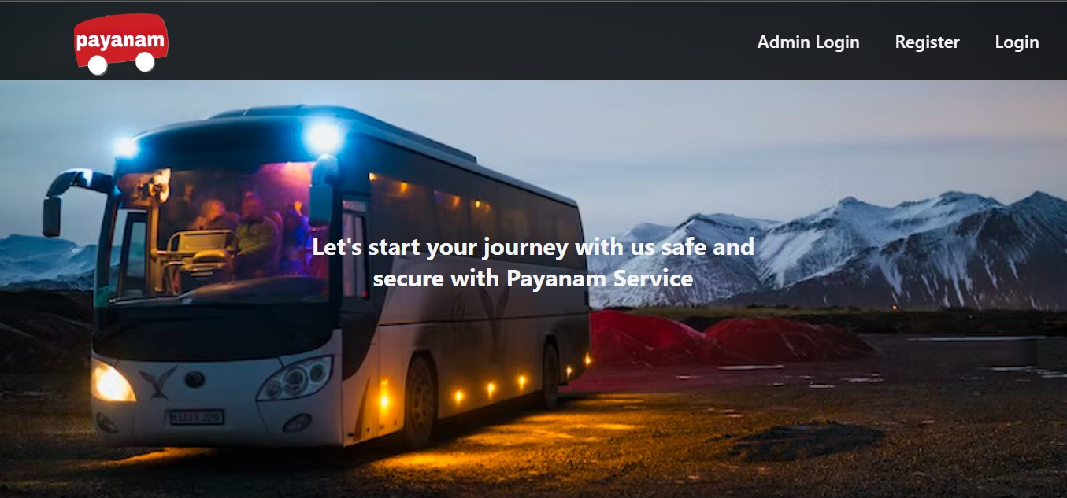

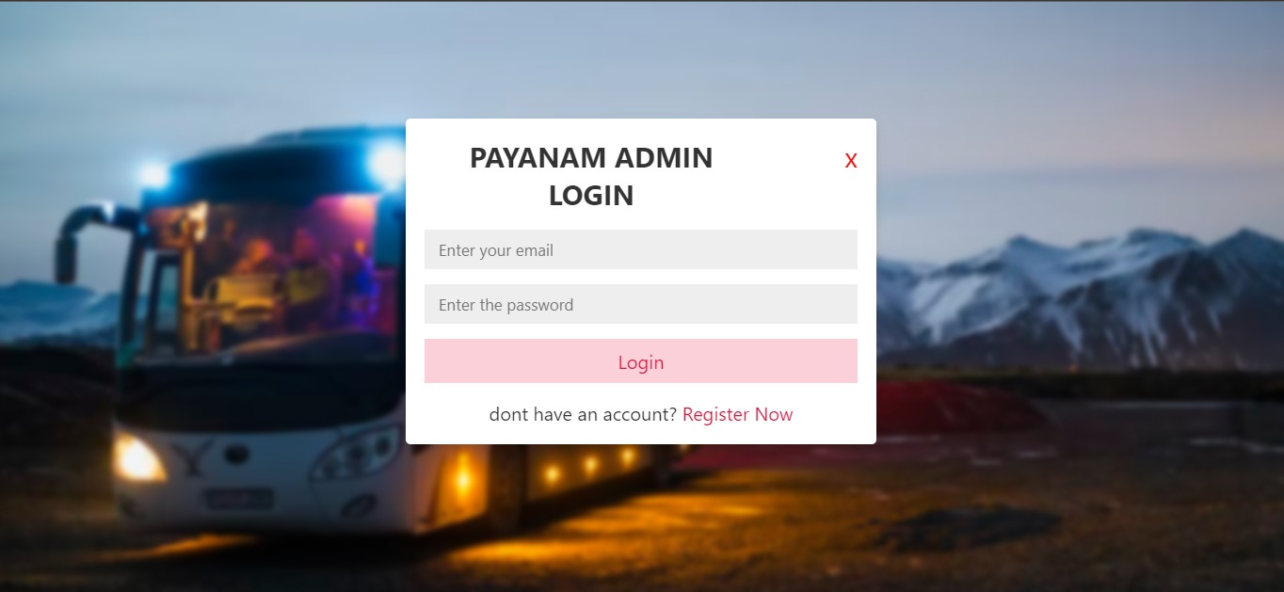

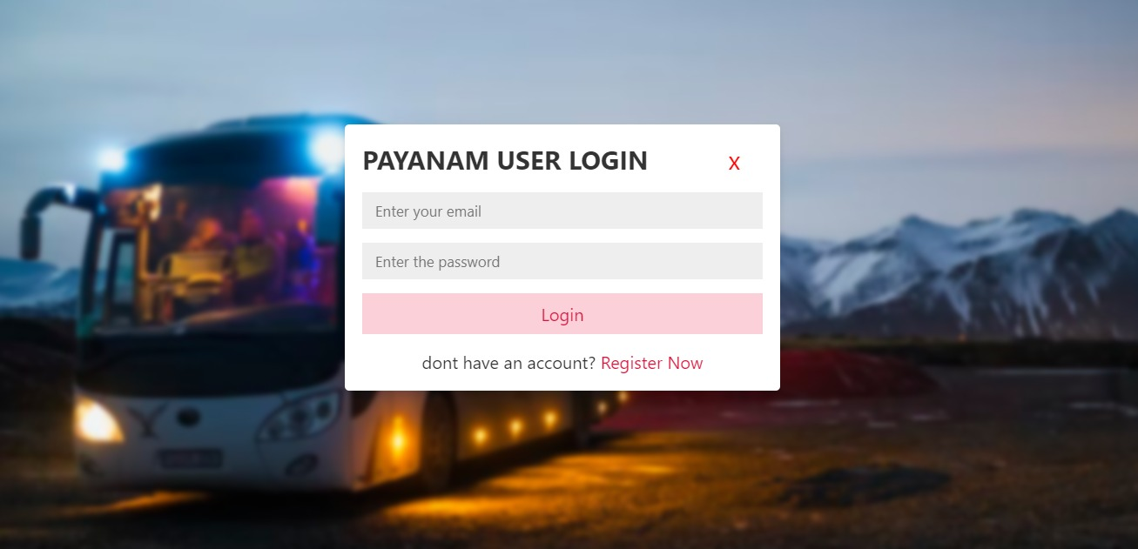

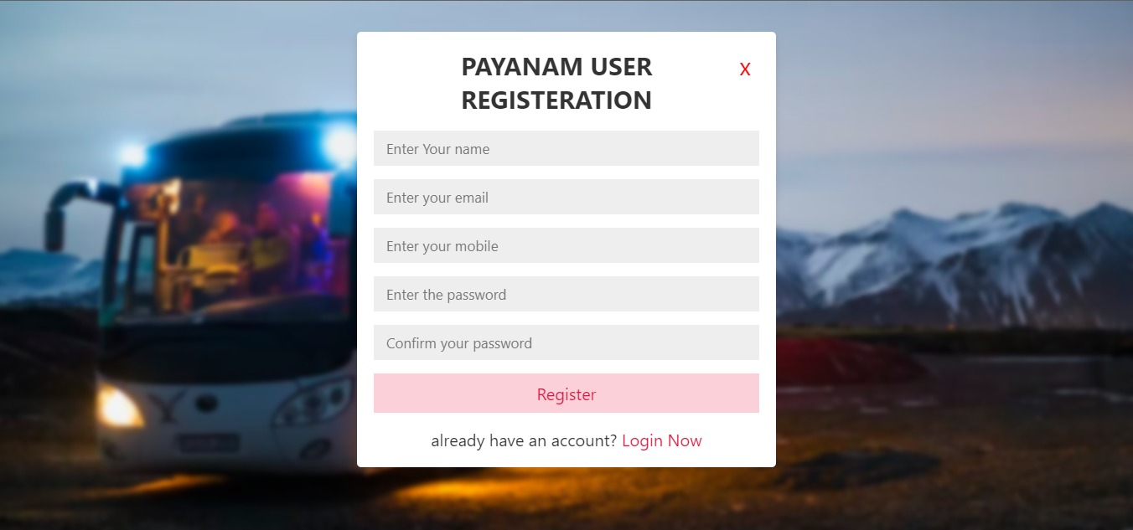

**USER HOME PAGE**

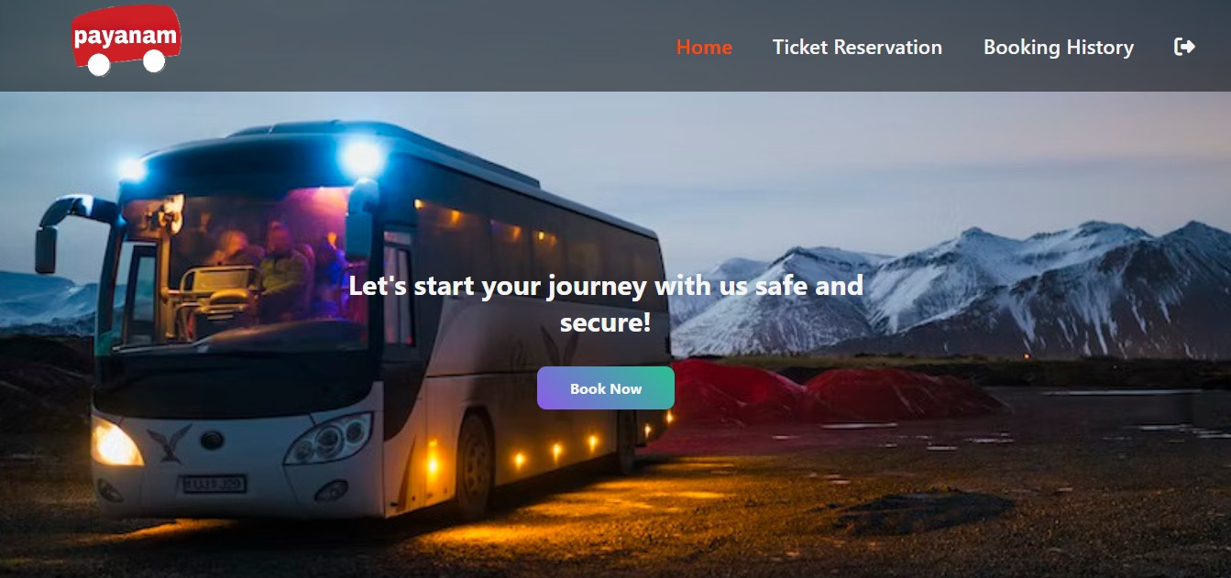

**BOOKING PAGE**

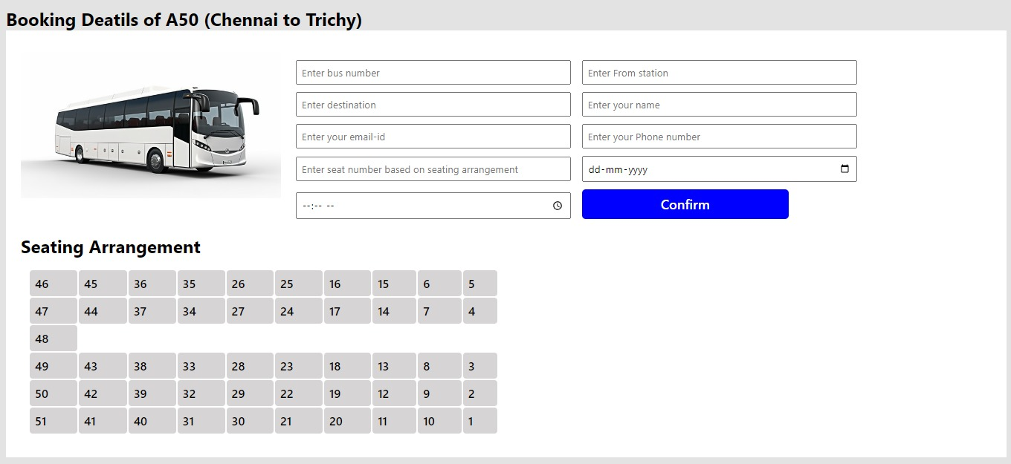

**USER TICKET RESERVATION PAGE**

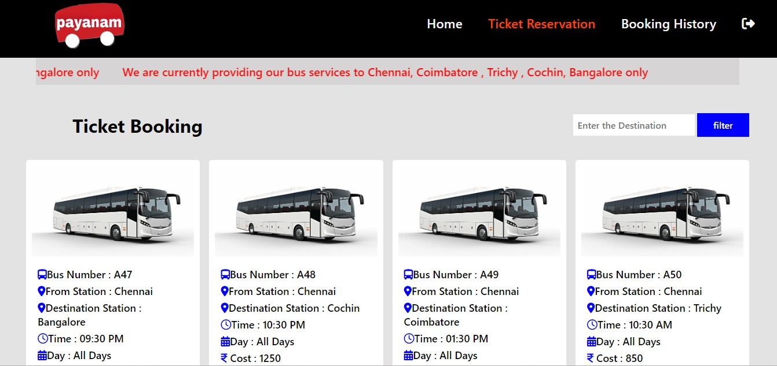

**USER BOOKING HISTORY PAGE**

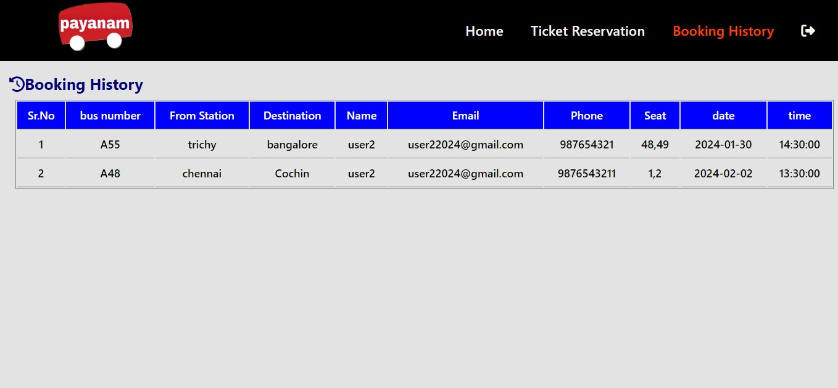

**ADMIN HOME PAGE**

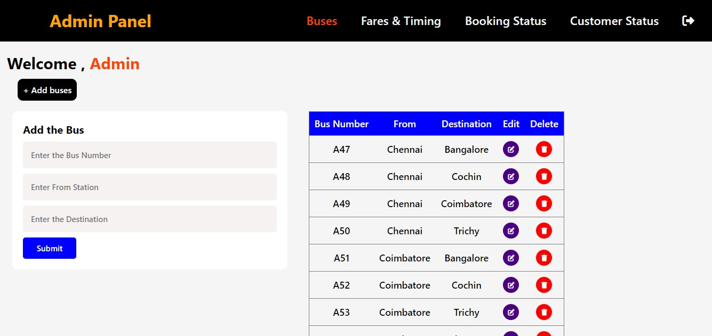

**ADMIN BUS EDIT PAGE**

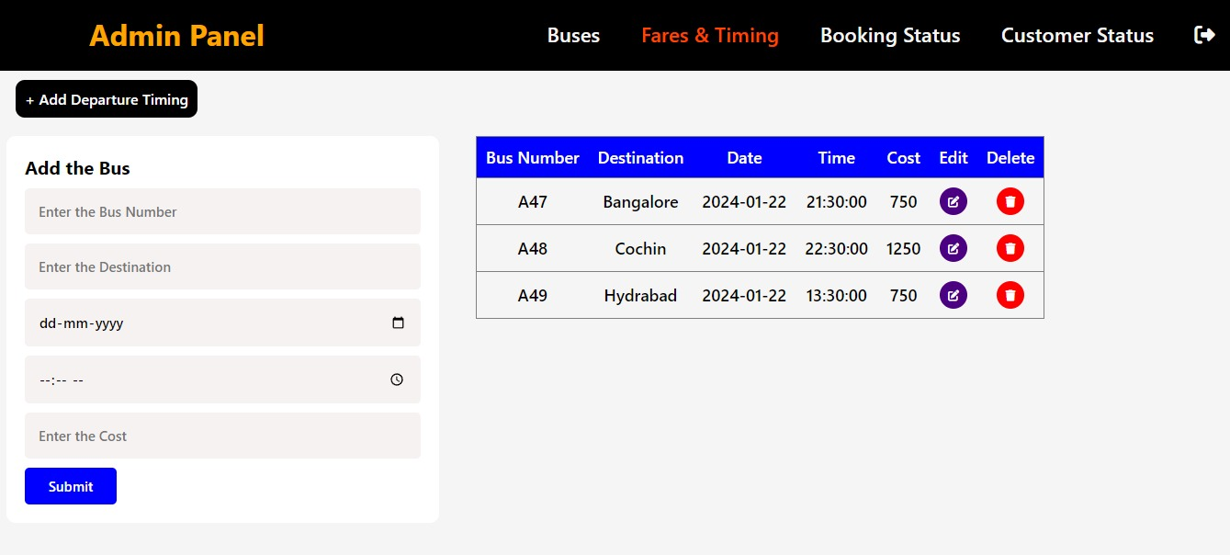

**ADMIN OVERALL PAGE**

